

MAPLFLUENCE INTERNAL HANDBOOK
Technical, Operational & Governance Manual

Preface

SECTION 0 — PREFACE
This internal handbook serves as the master reference for all architecture, workflows, operational procedures, and governance policies related to the Maplfluence platform at Clark & Enersen (C&E). It consolidates the technical knowledge, standards, and internal responsibilities required to build, maintain, operate, and support Maplfluence for institutions including universities, hospitals, research centers, and other large organizations.
This document is intended for internal C&E personnel only — including developers, GIS specialists, project managers, data engineers, architects, and operational leadership who support the platform. It is not intended for client distribution. A separate client-facing handbook is produced for end users.
PURPOSE OF THIS DOCUMENT
• To establish a single authoritative source of truth for Maplfluence’s system architecture, data models, security posture, development workflows, and governance.
• To ensure continuity of knowledge across staff changes, preventing platform risk or vendor lock-in.
• To formalize internal processes for deployment, debugging, floorplan processing, and scenario modeling.
• To align all team members around uniform standards for data integrity, Revit preparation, geometry processing, and client support.
WHAT THIS HANDBOOK COVERS
This handbook documents every operational area of Maplfluence, including:
• System architecture (frontend, backend, SSO, data services)
• Revit-to-Maplfluence floorplan export pipeline
• Data models (Firestone, Airtable, geometry schemas)
• Internal-only tools and workflows
• Scenario engine internals and logic
• Debugging guidelines and issue resolution patterns
• Integration models (SIS, HRIS, CMMS, GIS, optional)
• Governance, roles, and responsibilities
• Backup, security, and compliance structures
• All appendices, templates, and supporting material
WHO SHOULD USE THIS DOCUMENT
• Developers maintaining Maplfluence code
• GIS team members preparing or validating geometry
• PMs overseeing deployments or client communications
• Support staff handling user issues or escalations
• Leadership determining roadmap and responsibilities
• Any internal C&E stakeholder contributing to the platform
DOCUMENT UPDATE POLICY
This document evolves as Maplfluence evolves. Updates must be made:
• When new architectural components are added
• When integrations change
• When the Revit exporter pipeline is updated
• When platform governance or responsibilities change
• With each major release
Versioning should be maintained in the document footer or on the cover page. All updates should be approved by the platform owner.
CONFIDENTIALITY
This handbook contains internal operational procedures and should never be shared with clients. Client distributions use a separate, simplified handbook without internal architecture or backend details.
This Preface establishes the context, purpose, and rules for the handbook. The following sections expand into full technical and operational depth.
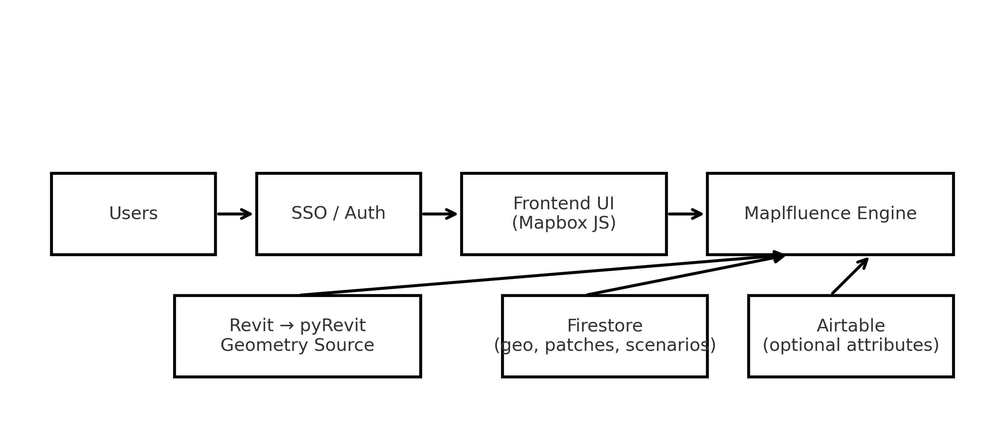

1. System Architecture Overview
The Maplfluence platform is built on a modular, scalable architecture designed to support interactive mapping,
SSO-protected data access, robust geometry management, and institutional workflows across higher education,
healthcare, government, and corporate environments.
ARCHITECTURAL PRINCIPLES
• Reliability — Geometry, attributes, and UI components must load consistently under varying network speeds.
• Maintainability — Code and data structures must remain understandable and editable across staff turnover.
• Modularity — Systems such as SSO, geometry services, and data sources must be separable and replaceable.
• Security — SSO-driven access control ensures no anonymous edits or unauthorized data access.
• Performance — Large campuses, complex floorplans, and multi-building scenarios must render efficiently.
CORE ARCHITECTURE LAYERS
1. Frontend (Mapbox GL JS)
- Renders buildings, floors, and rooms
- Loads GeoJSON layers
- Provides interactions such as hover, click, edit, export
2. Backend Data Services
- Firestore (primary): Geometry, overrides, scenarios, user roles, building/floor data
- Airtable (optional): Room attributes, editorial datasets
- ETL jobs: Syncs between systems when needed
3. Authentication & Authorization
- SSO (Azure AD, Google, Okta)
- Role-based access stored under universities/{universityId}/roles/{uid}
- Users gain viewer or editor capabilities based on directory groups
4. Geometry Services
- GeoJSON storage for floorplans, buildings, and room polygons
- Revit → pyRevit exporter → Maplfluence processing pipeline
- Alignment transforms ensure accurate placement over campus basemaps
5. Scenario Engine
- Reads baseline geometry and attributes
- Overrides room properties for move planning or renovations
- Produces scenario exports (tables and map layers)
- Safe read-only access for clients
6. Export Services
- CSV export for room lists, building summaries
- PDF capture tools for scenario presentations
DATA FLOW SUMMARY
User → SSO → Frontend → Firestore/Airtable → Geometry/Attributes → Frontend Map Rendering
Each request passes through authenticated channels ensuring security and data integrity.
SYSTEM SCALE CONSIDERATIONS
• Designed to support multi-campus institutions
• Efficient handling of thousands of rooms per campus
• Ability to store multiple geometry versions for historical tracking
• Modular integration points (SIS, HRIS, CMMS, Badge Access, GIS)
This architecture enables Maplfluence to remain stable, extensible, and maintainable across long-term client relationships.

2. Data Models
Maplfluence uses a unified, institution-scoped data model spanning geometry, attributes, overrides,
scenarios, and metadata. The model ensures stable identifiers, consistent relationships, and clean updates.
1. IDENTIFIER SYSTEM
• room_id (UUID) – Internal Maplfluence primary key.
• revit_id (GUID) – Persistent anchor from Revit; survives renumbering.
• building_id – Unique per building (“BDG001”).
• floor_id – building_id + floor code (“BDG001-FL02”).
2. GEOMETRY MODEL (GeoJSON)
Each room polygon includes:
{
"room_id": "...",
"revit_id": "...",
"room_number": "124",
"building_id": "BDG001",
"floor_id": "BDG001-FL2",
"geometry": { "type": "Polygon", "coordinates": [...] }
}
Building footprints and floor outlines follow similar structure but
with reduced attribute sets.
3. FIRESTORE MODEL (University-Scoped)
universities/{univId}/
buildings/{buildingId}
floors/{floorId}
rooms/{optional}
roomPatches/{roomId}
buildingPatches/{buildingId}
markers/{markerId}
paths/{pathId}
buildingConditions/{docId}
buildingAssessments/{docId}
scenarios/{scenarioId}/rooms/{roomId}
roles/{uid}
4. ATTRIBUTE MODEL (Airtable or Firestore)
Room attributes include:
• space_type
• department
• area_sqft
• occupant (optional)
• notes
• updatedAt / updatedBy
These remain editable by C&E/internal staff or client Editors depending on configuration.
5. CROSSWALKS
Crosswalk tables ensure:
Revit Room → Exported Geometry → Maplfluence Room
via consistent revit_id mapping.
6. UPDATE HANDLING
When geometry updates occur:
• revit_id anchors ensure stable merges.
• room_numbers may change but link to same room_id.
• attribute updates overwrite or append as rules require.
This data model ensures scalability, stability, and long-term maintainability across multi-year client engagements.
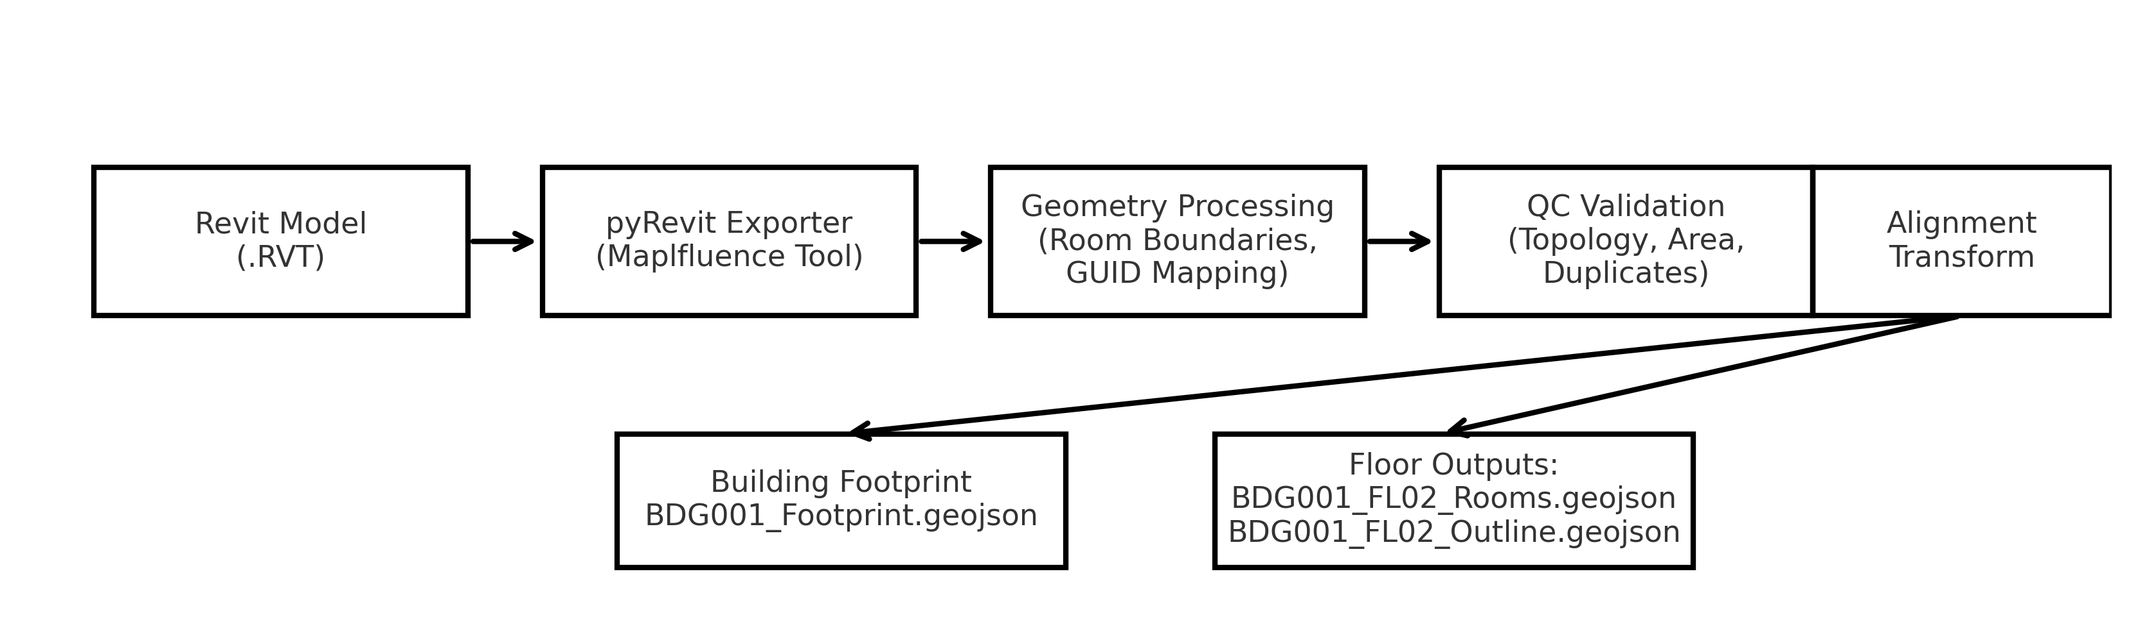

3. Deployment & Environment Management
Maplfluence deployments follow a controlled, versioned, and test-driven workflow to ensure stability and
consistency across institutional environments.
1. ENVIRONMENT STRUCTURE
• Local Development – Developer machine; unminified code; test datasets.
• Staging – Pre-production environment; used for testing UI, geometry updates, integrations.
• Production – Client-facing environment; locked to release versions.
2. CI/CD PIPELINE
Maplfluence uses a continuous integration workflow:
1. Code pushed to main repository
2. Automated build triggered
3. Unit checks and linting run
4. Staging bundle deployed
5. QA validates functionality
6. Production release approved and deployed
3. ENVIRONMENT VARIABLES
Key variables include:
• FIREBASE_API_KEY
• FIREBASE_PROJECT_ID
• MAPBOX_ACCESS_TOKEN
• SSO configuration (client ID, tenant ID, redirect URLs)
Variables differ by environment and must never be hard‑coded.
4. RELEASE MANAGEMENT
Each release includes:
• Version increment
• Change log
• QA signoff
• Staging validation
• Optional client preview
• Controlled promotion to production
5. ROLLBACK PROCEDURES
If a release causes issues:
• Revert to previous production build
• Validate critical functionality
• Patch identified errors
• Redeploy corrected bundle
6. GEOMETRY DEPLOYMENT
Floorplans and geometry updates require:
• QC validation
• Alignment testing
• Staging review
• Production upload
7. TESTING REQUIREMENTS
• Rendering tests (rooms, floors, buildings)
• Data integrity checks (attributes vs geometry)
• SSO authentication tests
• Export tests (CSV, PDF)
This deployment framework ensures reliable updates and protects production environments from disruptions.
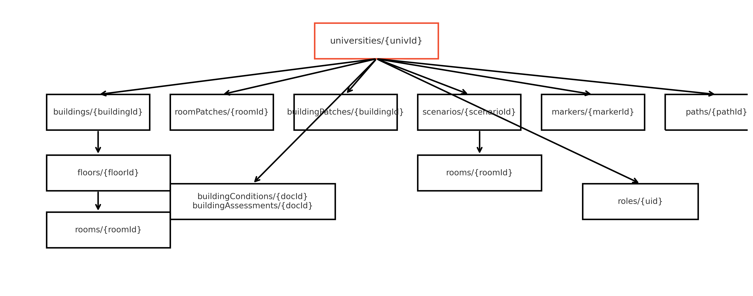

4. Floorplan Management (Internal Only)
Floorplan and geometry processing is a core internal responsibility of Clark & Enersen.
This ensures all institutions receive accurate, aligned, and validated spatial datasets.
1. REVIT MODEL PREPARATION
• All Rooms must be properly placed with enclosed boundaries.
• Room Separation Lines must be complete and non-overlapping.
• No duplicate room numbers.
• Linked models resolved before export.
• Required Revit parameters: Room Number, Name, Department, UniqueId (GUID), Area.
2. PYREVIT MAPLFLUENCE EXPORTER WORKFLOW
The exporter:
1. Identifies all Revit Rooms on each floor.
2. Extracts boundary polygons.
3. Captures required metadata (IDs, numbers, departments, areas).
4. Outputs cleaned GeoJSON for each floor.
5. Logs warnings for unbounded rooms, duplicates, missing parameters.
Typical output:
• buildingId_floorId_rooms.geojson
• buildingId_floorId_outline.geojson
• export_log.json
3. QC & GEOMETRY VALIDATION
Internal geometry QC includes:
• Closed polygon verification.
• No self-intersections.
• No overlaps between rooms.
• Centroid validation.
• Area comparison against Revit values.
QC Flags:
• Unbounded Rooms
• Zero area rooms
• Invalid geometry
• Missing GUID
4. GEOMETRY ALIGNMENT
GeoJSON is aligned to the campus basemap using:
• Translation
• Rotation
• Scaling
• Building footprint anchoring
5. VERSION CONTROL & FILE STORAGE
Geometry is versioned using naming conventions:
BDG001_FL02_Rooms_v3.json
Old files archived to maintain a full audit history.
6. ERROR RESOLUTION WORKFLOWS
Common geometry issues:
• Misalignment – adjust transform matrix.
• Missing rooms – correct Revit model and re-export.
• Overlaps – fix Room Separation Lines.
• Incorrect centroids – recompute geometry.
This section establishes the full internal workflow for accurate geometry generation from Revit models into Maplfluence.
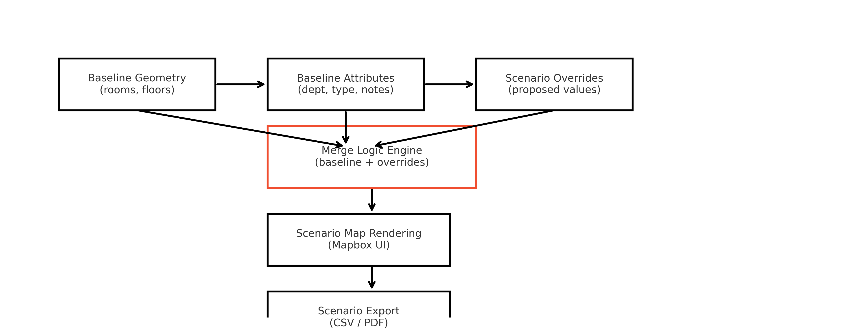

5. Scenario Engine (Internal)
The Scenario Engine enables C&E to model proposed future states without altering the institution’s baseline data.
Clients are restricted to viewing scenarios, while C&E internal planners build, validate, and publish them.
1. SCENARIO PURPOSE
Scenarios allow:
• Move planning
• Department reorganizations
• Renovation impact studies
• Swing space analysis
• Future state modeling
2. DATA STRUCTURE (FIRESTORE)
Each scenario is stored under:
universities/{universityId}/scenarios/{scenarioId}
Scenario-level metadata:
{
"name": "Summer Move Plan",
"description": "Proposed departmental moves",
"createdAt": 1712092000,
"createdBy": "planner@clarkenersen.com"
}
Per-room overrides stored at:
scenarios/{scenarioId}/rooms/{roomId}
Typical override document:
{
"proposed_department": "Physics",
"proposed_type": "Laboratory",
"notes": "Pending renovation",
"status": "proposed_move"
}
3. OVERRIDE LOGIC
Scenario data never edits baseline geometry or attributes.
Instead:
• Baseline room data is loaded.
• Scenario overrides replace selected fields.
• The frontend merges baseline + scenario at runtime.
4. GEOMETRY HANDLING
Most scenarios only modify attributes; geometry changes occur when:
• Renovations alter room boundaries
• Rooms are added or removed
• Spaces are subdivided
Scenario geometry is stored separately and only loaded in scenario mode.
5. RENDERING BEHAVIOR
The frontend highlights:
• Proposed department
• Proposed space type
• Special statuses (swing, temporary, offline)
Scenario states are visually distinguished for clarity.
6. EXPORTS
Scenario exports include:
• CSV summary of all proposed changes
• PDF showing scenario map view
• Lists of affected buildings, floors, and departments
7. INTERNAL CONTROLS
Only C&E staff can:
• Create scenarios
• Modify scenario data
• Approve/publish scenarios
• Remove or archive scenario records
Clients only view scenarios as read‑only.
This structure ensures safe and accurate modeling of future conditions without risking baseline data integrity.
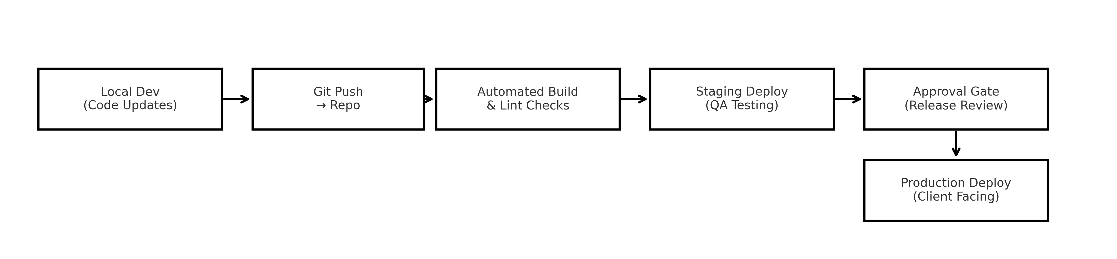

6. Internal Debugging Guide
This section documents internal debugging procedures for diagnosing rendering, geometry, data, export,
and authentication issues. It is used by C&E engineering, GIS, and support personnel.
1. MAP RENDERING ISSUES
Symptoms:
• Blank floors
• Missing buildings
• Hover/click not responding
• Console errors such as “layer does not exist”
Causes:
• Incorrect layer load order
• Missing GeoJSON file
• Typo in layer ID
• Firestore permissions blocking data load
Fix:
• Validate layer list in map.getStyle().layers
• Inspect network tab for failed requests
• Confirm correct Firestore paths
• Rebuild layers in correct sequence
2. GEOMETRY ISSUES
Symptoms:
• Misaligned floorplans
• Clicking selects wrong room
• Missing or duplicated rooms
Causes:
• Misaligned transform matrix
• Overlapping or open polygons
• Missing GUIDs in Revit model
Fix:
• Recalculate transform
• Repair geometry in Revit and re-export
• Use internal Geometry Inspector tool
3. FIRESTORE DATA ISSUES
Symptoms:
• “Missing or insufficient permissions”
• No room attribute updates
• Scenario data not loading
Causes:
• Invalid rules after update
• Wrong document path
• Role mismatch for user
Fix:
• Validate isAdmin() logic
• Check existence of role documents
• Confirm univId path is correct
4. AIRTABLE SYNC FAILURES
Symptoms:
• Missing attributes in app
• Export missing rows
Causes:
• API rate limits
• Schema mismatch
• Duplicate room entries
Fix:
• Refresh base connection
• Validate column names
• De-duplicate rows
5. SSO / AUTHENTICATION FAILURES
Symptoms:
• Login loop
• Auth popup errors
• Editors seeing viewer permissions
Causes:
• Token mismatch
• Role mapping not created
• Redirect URI incorrect
Fix:
• Confirm IDP settings
• Check Firestore roles/{uid} doc
• Decode JWT for debugging
6. EXPORT ERRORS
Symptoms:
• CSV missing fields
• PDF fails to generate
Causes:
• Filter applied unexpectedly
• Attribute mismatch
• Large scenario load timeout
Fix:
• Clear filters
• Validate attribute schema
• Retry with simplified scenario
7. INTERNAL DEBUGGING TOOLS
C&E uses:
• Geometry Inspector
• Firestore Path Validator
• Mapbox Layer Inspector
• Network Analyzer
• Revit Export Log Analyzer
These tools allow efficient reproduction and triage of issues.
This guide standardizes internal debugging practices to ensure consistent and fast resolution across environments.
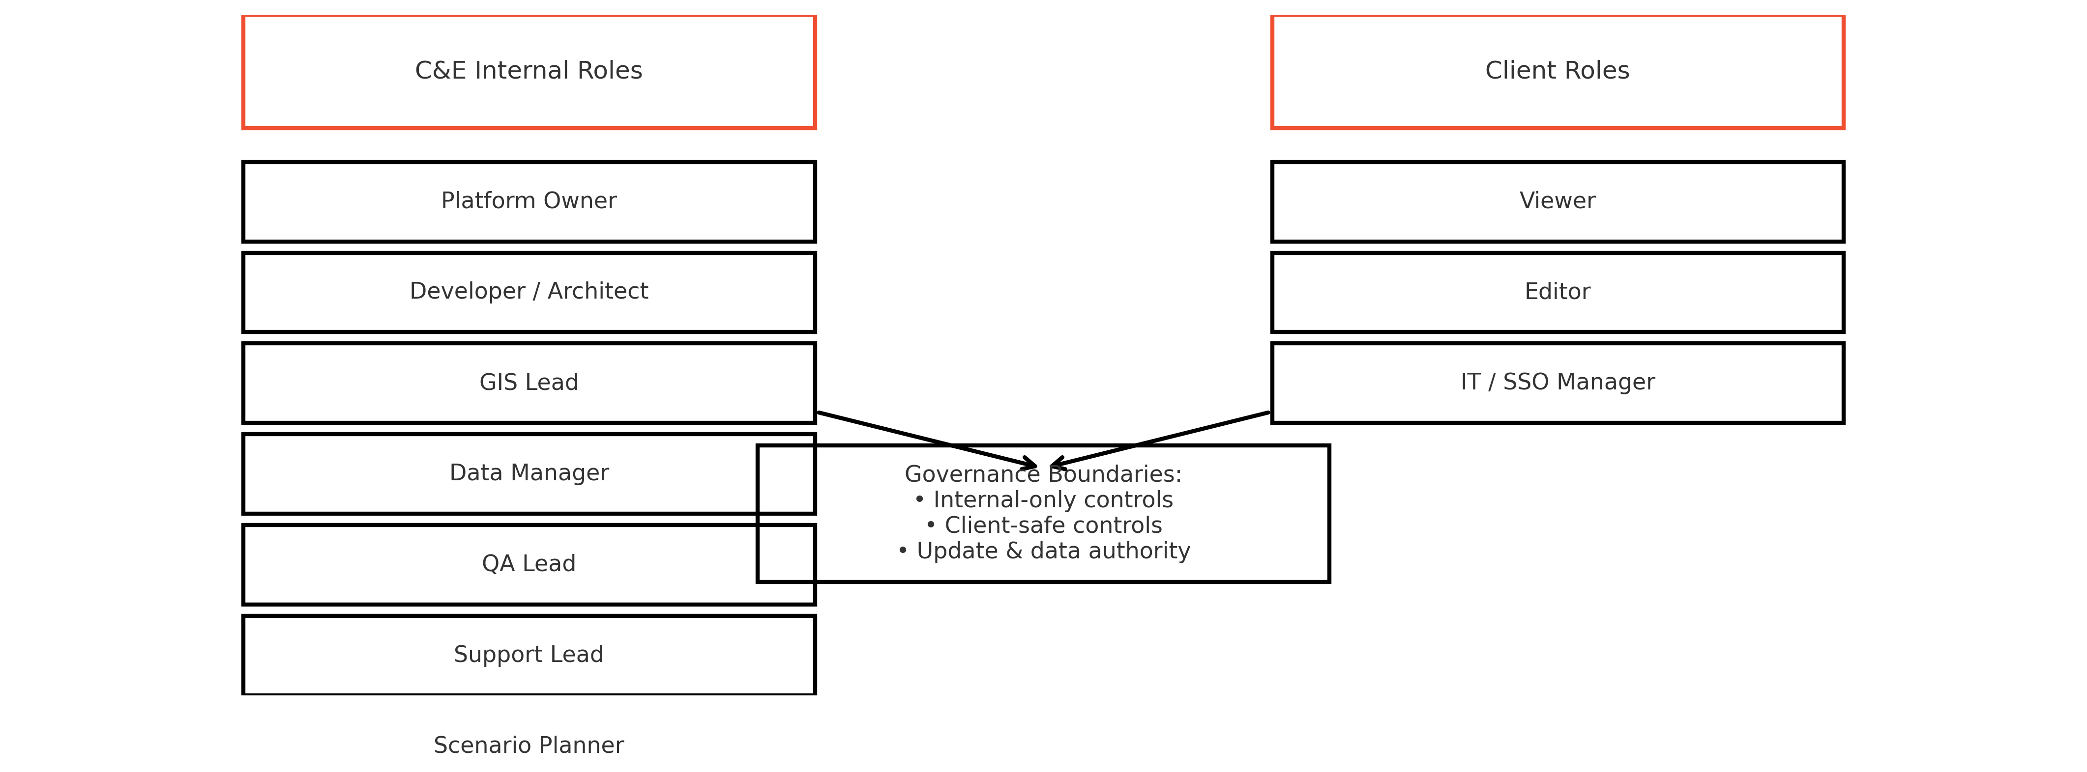

7. Integrations (Optional)
Maplfluence supports multiple optional integrations that enhance planning workflows but are not required for
core system functionality. All integrations are read‑only unless explicitly configured with institutional approval.
1. SIS (STUDENT INFORMATION SYSTEMS)
Supported Platforms:
• Banner
• Workday Student
• PeopleSoft
• Colleague
Typical Fields Mapped:
• Section counts
• Enrollment totals
• Room assignments (if available)
• Academic term data
Use Cases:
• Classroom utilization analysis
• Scheduling reviews
• Long‑range academic planning
2. HR / DIRECTORY INTEGRATIONS
Supported Sources:
• Workday HR
• Active Directory groups
• PeopleSoft HR
Fields Typically Used:
• Department assignment
• Employee role
• Occupancy locations (if institution tracks)
Use Cases:
• Department space allocation
• Staffing alignment reviews
3. WORK ORDER / CMMS (COMPUTERIZED MAINTENANCE MANAGEMENT SYSTEMS)
Supported Systems:
• TMA
• AssetWorks
• Maximo
• SchoolDude/Brightly
Integration Patterns:
• Count of work orders by building/room
• Facility condition overlays
• Maintenance prioritization analyses
4. BADGE ACCESS / SECURITY SYSTEMS
Badge access data provides:
• Aggregated entry counts
• Occupancy insights
• After‑hours trends
Privacy:
Maplfluence uses only aggregated data — never individual badge scans.
5. GIS / ARCGIS ONLINE INTEGRATIONS
Used For:
• Campus parcel and boundary overlays
• Utility layers
• Outdoor routing
• ADA/Accessibility mapping
Patterns:
• Feature services
• Static GeoJSON
• WMS/WMTS overlays
6. DATA WAREHOUSE / BI SYSTEMS
Institutions often maintain data lakes containing:
• Enrollment trends
• Staff projections
• Financial datasets
Maplfluence ingests selected fields for planning dashboards.
7. DATA CONTRACTS & FIELD MAPPING
All integrations follow a clear contract model:
{
"room_id": "RM_87f02",
"building_id": "BDG001",
"floor_id": "BDG001-FL02",
"attribute": "value",
"source": "SIS/HRIS/CMMS"
}
8. COMMON INTEGRATION CHALLENGES
• ID mismatch between systems
• Stale data
• Schema drift
• API rate limits
• Partial updates
Mitigation:
• Scheduled refreshes
• Crosswalk tables
• Validation routines
These optional integrations enhance planning accuracy while maintaining Maplfluence’s modular architecture.

8. Governance, Roles & Policies
Maplfluence governance ensures clarity, continuity, and security across all institutional deployments.
This section defines internal roles, client roles, responsibilities, update policies, and continuity measures.
1. GOVERNANCE PRINCIPLES
• Maintain system integrity and data accuracy.
• Ensure role clarity and proper separation of responsibilities.
• Protect client environments from unauthorized changes.
• Maintain long‑term platform continuity independent of individuals.
• Support transparent update processes and communication.
2. INTERNAL C&E ROLES
Platform Owner:
• Owns roadmap and governance standards.
• Approves major updates and architectural changes.
Lead Developer / Technical Architect:
• Maintains codebase and backend integrations.
• Oversees deployment pipeline and environment configuration.
GIS Lead:
• Manages Revit exporter workflow.
• Validates geometry and corrects alignment issues.
Data Manager:
• Owns Airtable/Firestore schema.
• Manages data integrity and crosswalks.
QA Lead:
• Tests releases in staging.
• Validates exports, rendering, and SSO.
Support Lead:
• Handles client issues and escalations.
• Provides training and onboarding.
Scenario Planner (Internal):
• Builds and maintains all scenarios.
• Publishes finalized versions for clients.
3. CLIENT ROLES
Viewer:
• Read‑only access.
• Can export data.
Editor:
• Can modify room‑level attributes only.
• Cannot modify geometry, floors, buildings, or scenarios.
Client IT / SSO Manager:
• Manages directory groups and SSO configuration.
4. UPDATE GOVERNANCE
• All updates require staging validation.
• Major updates require written release notes.
• Hotfixes permitted only with Platform Owner approval.
• Documentation updated with each major release.
5. DATA GOVERNANCE
C&E controls:
• Geometry files
• Exporter pipeline
• Alignment transforms
• Scenario creation and modification
• Backend configuration
Clients control:
• Room‑level attribute edits
• Department assignments
• Notes and metadata
6. SUPPORT & INCIDENT MANAGEMENT
Severity Levels:
• Critical: system down — immediate response.
• High: geometry or attribute failures — same-day.
• Medium: UX issues — 1–3 days.
• Low: enhancements — scheduled.
Escalation Path:
Support → Developer/GIS → Platform Owner.
7. CONTINUITY & RISK MITIGATION
• All workflows documented in this handbook.
• Revit exporter source stored in secure repository.
• Geometry archives maintained.
• No dependency on a single staff member.
This governance model ensures stability and clear operational boundaries for all Maplfluence deployments.

9. Backup, Security & Compliance
This section defines Maplfluence’s security posture, data‑protection expectations, and backup requirements.
1. SECURITY PRINCIPLES
• Zero anonymous access.
• All data operations require authenticated identities.
• Client attribute edits are restricted to designated editor roles.
• Administrative operations restricted to internal C&E personnel.
• All traffic occurs over HTTPS.
2. FIRESTORE SECURITY RULES
The following Firestore ruleset governs read/write privileges:
rules_version = '2';
service cloud.firestore {
match /databases/{database}/documents {
function isSignedIn() {
return request.auth != null;
}
function isAdmin(universityId) {
return isSignedIn() &&
get(/databases/$(database)/documents/universities/$(universityId)/roles/$(request.auth.uid)).data.role == "admin";
}
match /universities/{universityId} {
match /buildings/{buildingId} {
allow read: if true;
allow write: if isAdmin(universityId);
match /floors/{floorId} {
allow read: if true;
allow write: if isAdmin(universityId);
match /rooms/{roomId} {
allow read: if true;
allow write: if isAdmin(universityId);
}
}
}
match /roomPatches/{roomId} {
allow read: if true;
allow create, update, delete: if isAdmin(universityId);
}
match /buildingPatches/{buildingId} {
allow read: if true;
allow create, update, delete: if isAdmin(universityId);
}
match /markers/{markerId} {
allow read: if true;
allow create: if true;
allow update, delete: if isAdmin(universityId);
}
match /paths/{pathId} {
allow read: if true;
allow write: if isAdmin(universityId);
}
match /buildingConditions/{docId} {
allow read: if true;
allow write: if isAdmin(universityId);
}
match /buildingAssessments/{docId} {
allow read: if true;
allow write: if isAdmin(universityId);
}
match /drawingEntries/{docId} {
allow create: if true;
allow read, update, delete: if isAdmin(universityId);
}
match /roles/{uid} {
allow read: if isSignedIn() && request.auth.uid == uid;
allow write: if isAdmin(universityId);
}
}
match /{document=**} {
allow read, write: if false;
}
}
}
3. BACKUP STRATEGY
C&E maintains:
• Geometry archives (full version history)
• Exporter logs
• Floor outline and room polygons per version
• Scenario snapshots (per release)
Firestore backups:
• Daily incremental
• Weekly full export
• Retained for 90 days minimum
4. DATA RESTORE PROCEDURE
• Identify affected building/floor.
• Restore previous GeoJSON from archive.
• Reupload geometry to Firestore.
• Validate alignment.
• Confirm with institution before publishing.
5. COMPLIANCE
• FERPA – No student‑level identifying data stored.
• HIPAA – No medical records or PHI stored.
• SSO – Identity provider enforces MFA and password policies.
6. AUDIT LOGS
Institutional SSO provides user login logs.
Firestore retains write metadata via updatedAt and updatedBy fields.
This framework ensures security, recoverability, and long‑term system protection.

10. Appendices
The appendices provide reference materials used throughout Maplfluence development and operations.
1. GEOMETRY SCHEMA
Room Schema:
• room_id
• revit_id
• room_number
• department
• space_type
• area_sqft
• building_id
• floor_id
• geometry (Polygon)
2. FIRESTORE SCHEMA SUMMARY
universities/
buildings/
floors/
roomPatches/
scenarios/
roles/
markers/
paths/
buildingConditions/
buildingAssessments/
3. AIRTABLE SCHEMA SUMMARY
Typical fields:
• room_id
• revit_id
• department
• occupant
• notes
• updatedAt / updatedBy
4. SCENARIO SCHEMA
scenarios/{scenarioId}
scenarios/{scenarioId}/rooms/{roomId}
Fields include:
• proposed_department
• proposed_type
• status
• notes
5. REVIT EXPORTER CHECKLIST
• All rooms bounded
• Unique GUIDs
• Department assigned
• Area validated
• Floorplan clean of stray lines
6. ERROR CODES
• G001 – Invalid geometry
• G002 – Missing GUID
• A101 – Airtable sync failure
• S501 – SSO misconfiguration
• F301 – Firestore permission denied
7. QA CHECKLIST
• Validate building list
• Validate floor toggles
• Validate room selection
• Validate exports (CSV/PDF)
• Validate SSO roles
• Validate scenarios render correctly
8. DEPLOYMENT TEMPLATE (SUMMARY)
• Version number
• Change log
• QA signoff
• Staging test results
• Production release date
These appendices provide operational reference for all internal C&E Maplfluence personnel.

